OEM RU upgrade and patching

Contents
1.Introduction 3
2.Prerequisite 3
3.Applying Release update in OMS 3
4.APPly agent patch for RU 6
5.Middleware patches 9
6.JDK upgrade in OMS 18
7.JDK upgrade in Agent 19

1.Introduction

Release Updates (RUs) enable us to roll out new features and bug fixes quickly so you don't have to wait for a new major release.
General recommendation is to apply the most current Release Update as soon as possible.

2.Prerequisite

Backup middleware home and oracle inventory before patching.
- emctl stop oms -all
- emctl status oms
- tar -pcvf <backup_directory>/middleware_home.tar <middleware_home>/middleware
- tar -pcvf <backup_directory>/gc_inst_bkp.tar gc_inst
- tar -pcvf <backup_directory>/oracle_inventory_bkp_16JAN23.tar oraInventory
- emctl start oms

3.Applying Release update in OMS

- Upgrade Omspatcher
Omspatcher utility used for automating the process of applying System patches on Oracle Management Service.
Verify omspatcher version using below command needed for applying the RU.
$middleware_home/omspatcher version
If omspatcher needs to updated, download latest patch for Omspatcher from Oracle site and unzip it in middleware home.
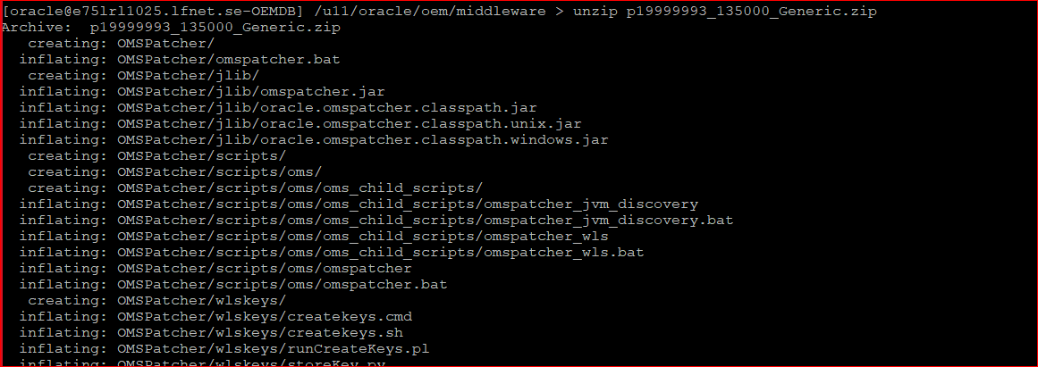
Verify the version after unzipping the file.
- Apply RU
Once Omspatcher updated, please proceed with analyzing and applying RU.
- Meet all the prerequisites mentioned in patch.
- Unzip patch into stagging directory
- cd <PATCH_TOP_DIR>/34601305
- /u11/oracle/oem/middleware/OMSPatcher/omspatcher apply -analyze
- /u11/oracle/oem/middleware/OMSPatcher/omspatcher apply
Sample logs:
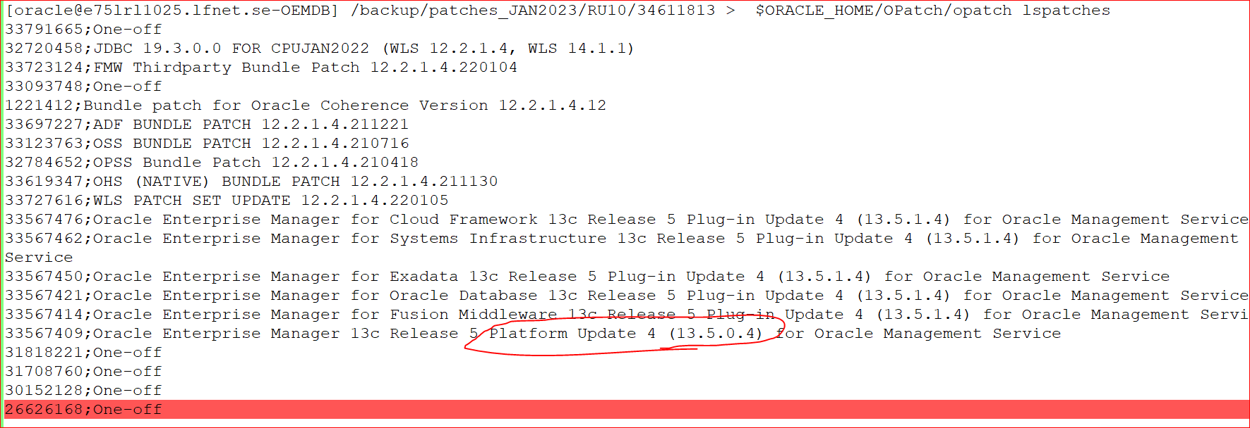
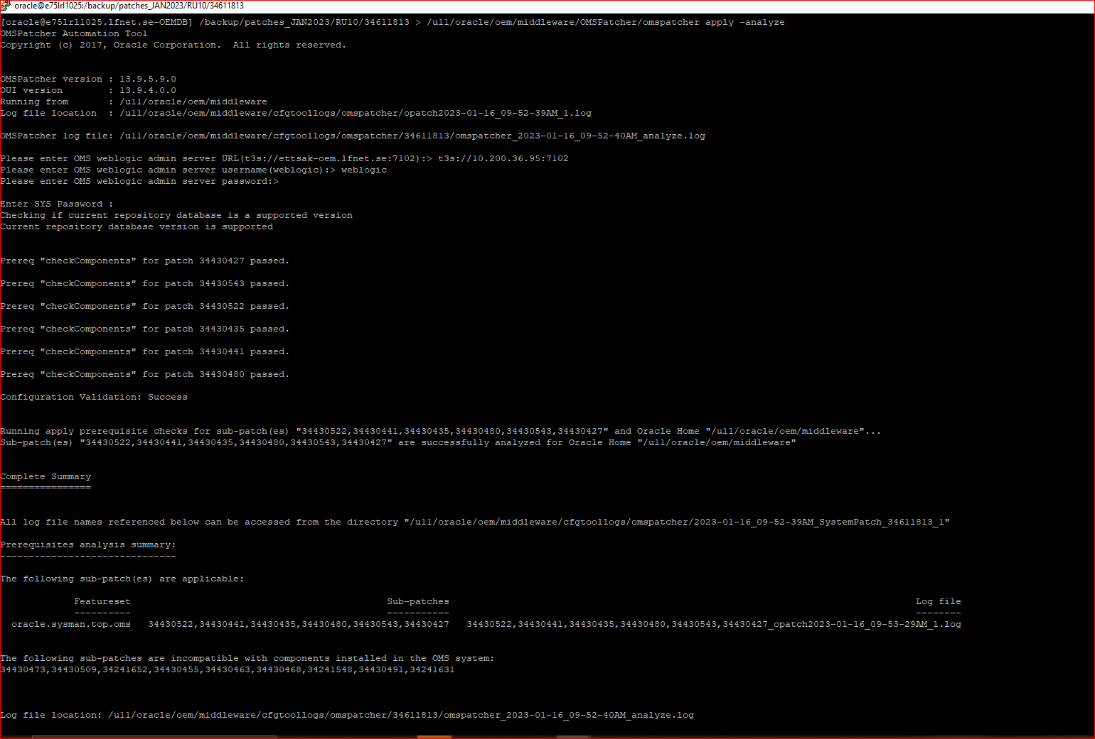
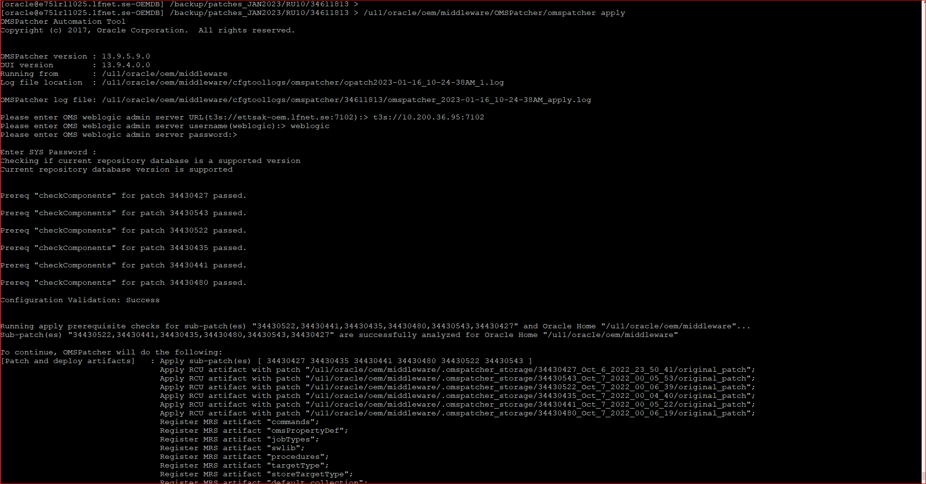
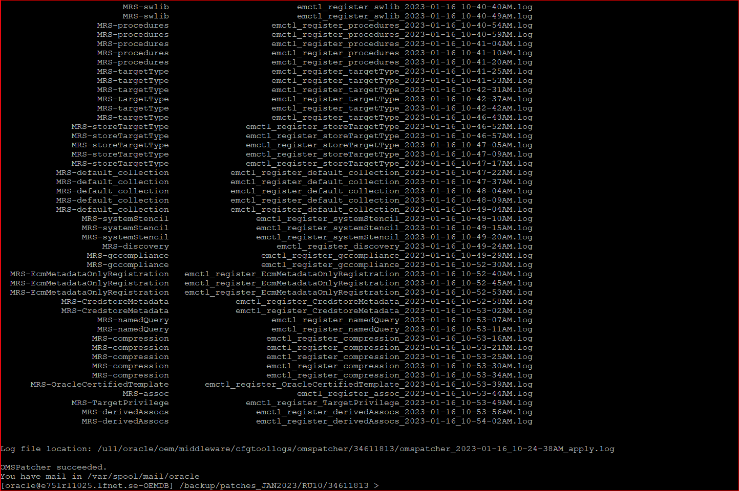
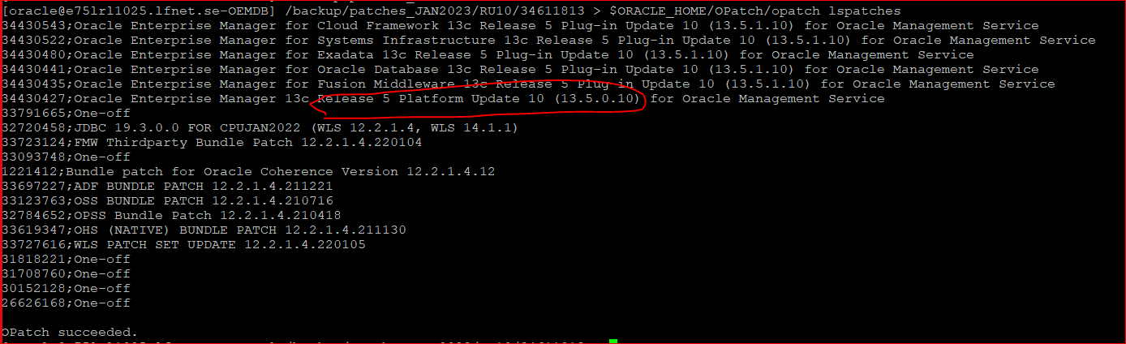

4.APPly agent patch for RU
Once RU applied in OMS, apply agent patch for same RU.
- In Cloud Control, from the Enterprise menu, select Patching and Provisioning, and then click Patches and Updates.
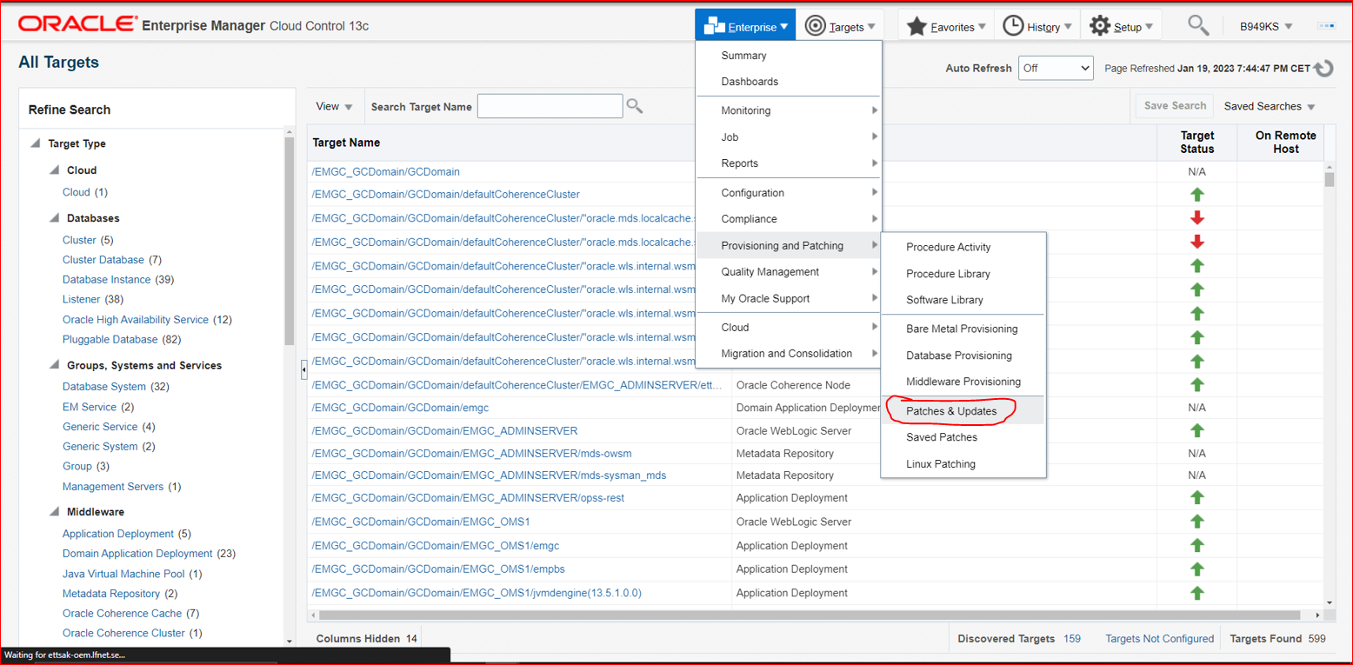
- On the Patches and Updates page, in the Patch Search Region, enter the patch number and search.

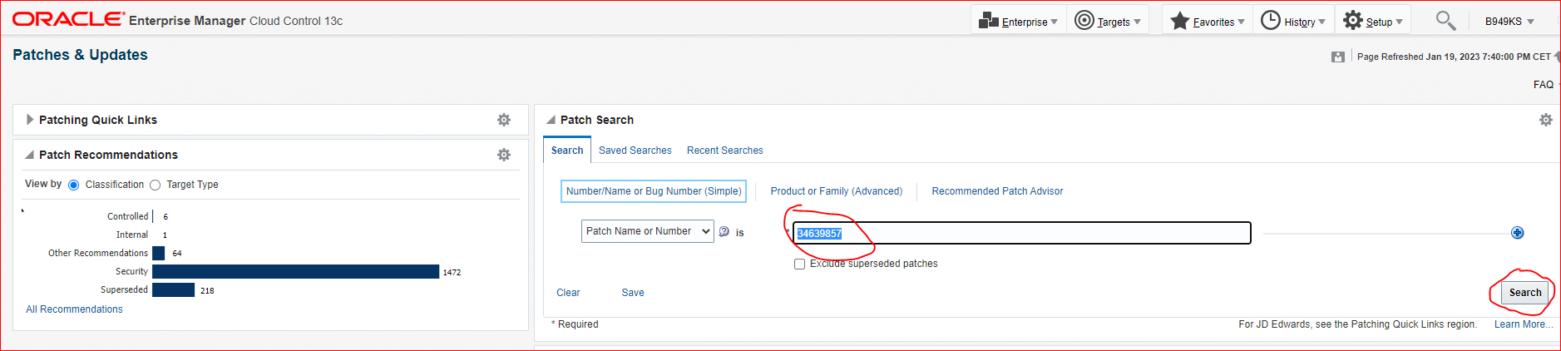

- Select the patch, and from the context menu click Create plan.

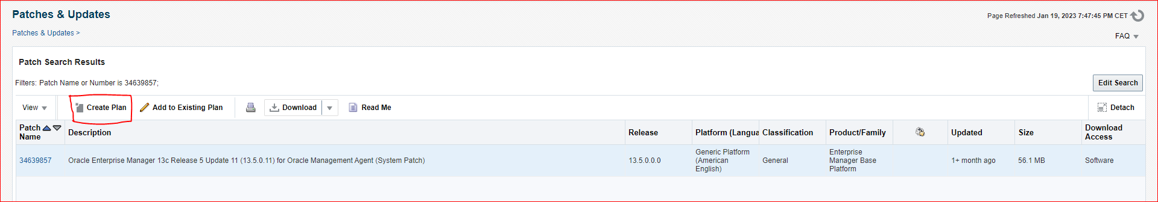
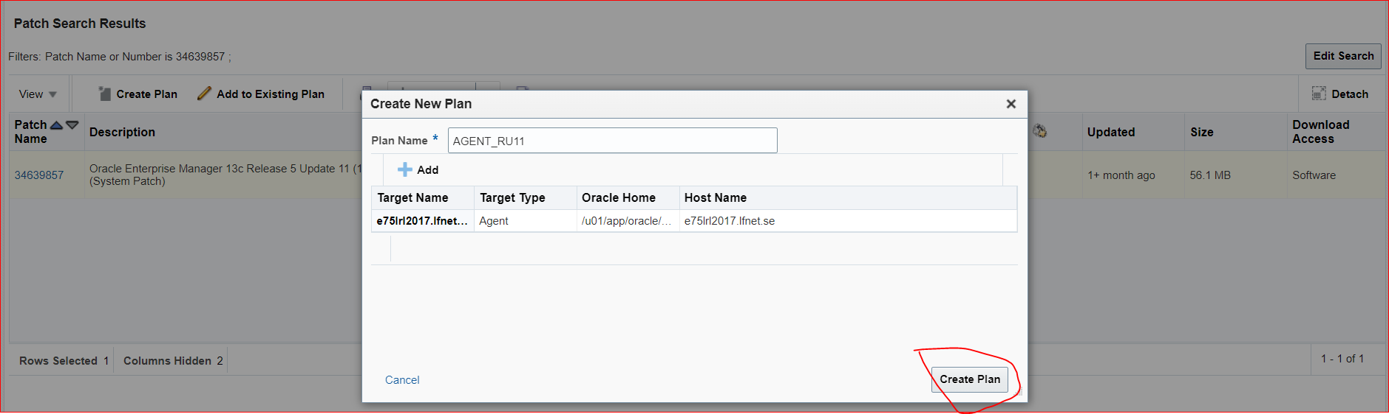

- On the Patches and Updates page, in the Plans region, click the Patch Plan you created in the previous step.

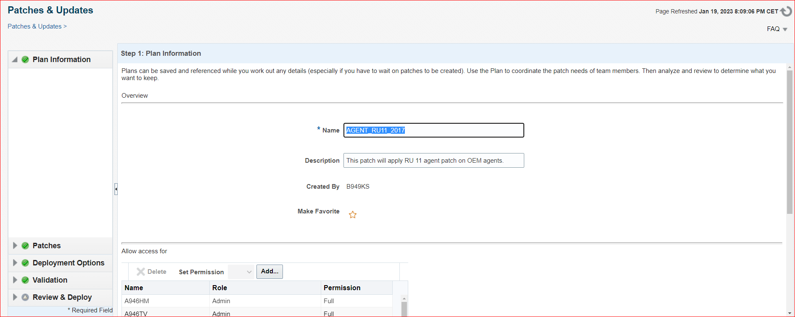

- On the Validation page, click Analyze to check for conflicts. If there are conflicts, then review the issues, and resolve it according to the corresponding solutions available on the page. After resolving the issue, click Re-Analyze.

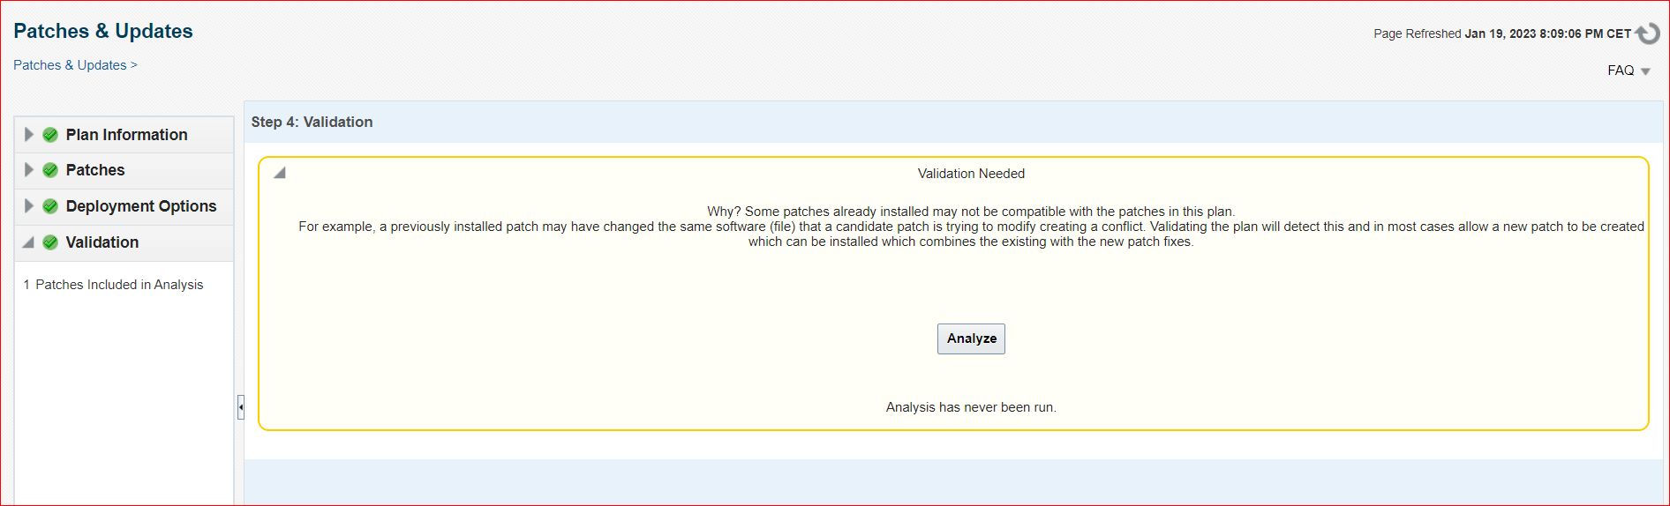
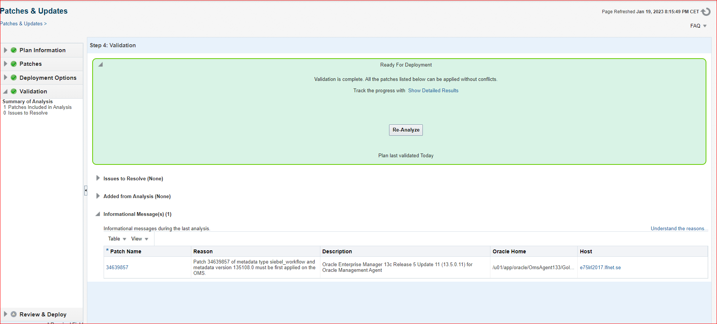

- On the Review & Deploy page, review the details you have provided for the patch plan, then click Deploy.

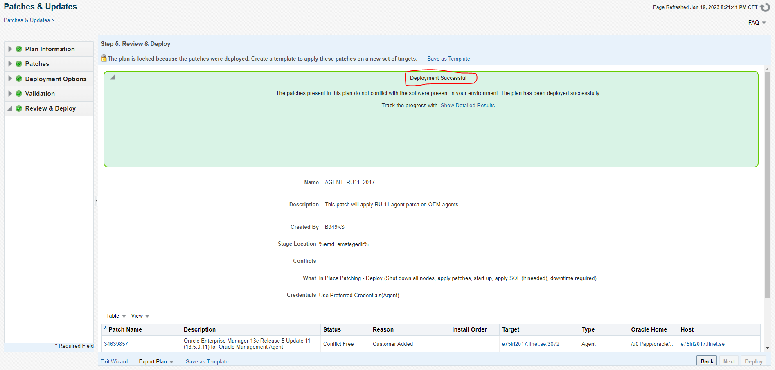

5.Middleware patches

- Opatch update in middleware home
Opatch is used to apply patches in middleware. Use below commands to verify the version.
- cd <MIDDLEWARE_HOME>/OPatchan
- ./opatch version
To update opatch version, download latest patch from oracle site and follow below steps.
Unzip p28186730_1394210_Generic.zip into staging directory
- cd 6880880/
- export ORACLE_HOME="/u11/oracle/oem/middleware"
- echo $ORACLE_HOME
- export JAVA_HOME="/u11/oracle/oem/middleware/oracle_common/jdk"
- $ORACLE_HOME/oracle_common/jdk/bin/java -jar <PATCH_HOME>/6880880/opatch_generic.jar -silent oracle_home=$MIDDLEWARE_HOME
- cd <MIDDLEWARE_HOME>/OPatch
- ./opatch version
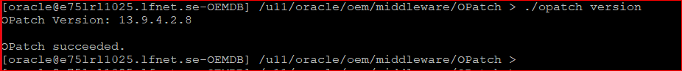
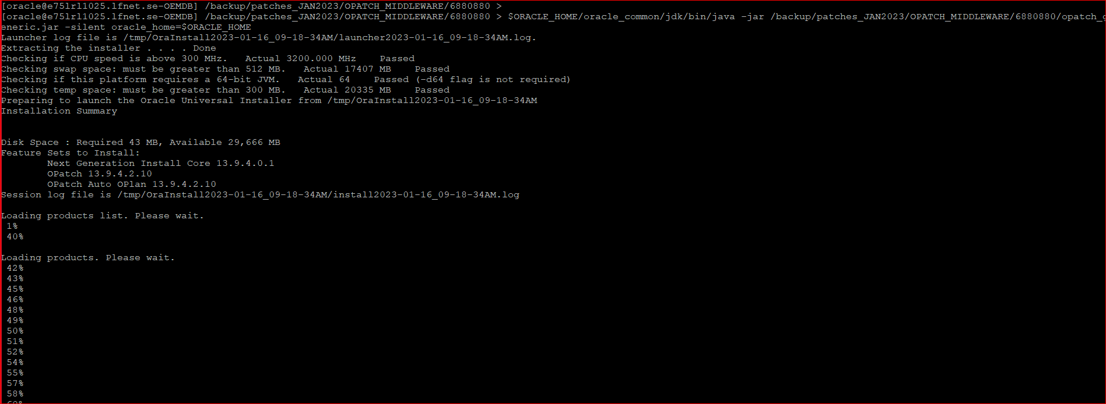
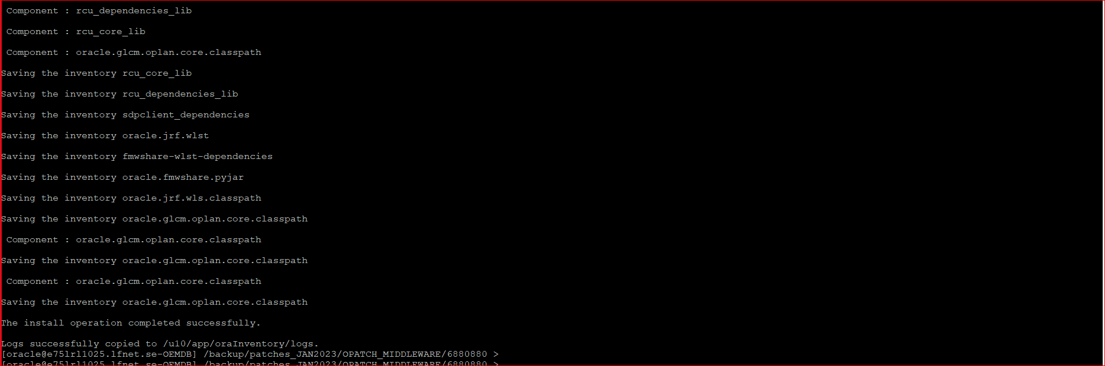

- Apply patches
Download recommended patches from oracle site and apply.Below patches has been applied to upgrade the JDK version in OMS. Follow readme document provided in patch file to apply patches.
- export ORACLE_HOME="/u11/oracle/oem/middleware"
- export JAVA_HOME="/u11/oracle/oem/middleware/oracle_common/jdk"
- export OPATCH_HOME=$ORACLE_HOME/OPatch
- export PATH=$JAVA_HOME/bin:$OPATCH_HOME:$PATH

- Patch 34653267 WLS PATCH SET UPDATE 12.2.1.4.220929
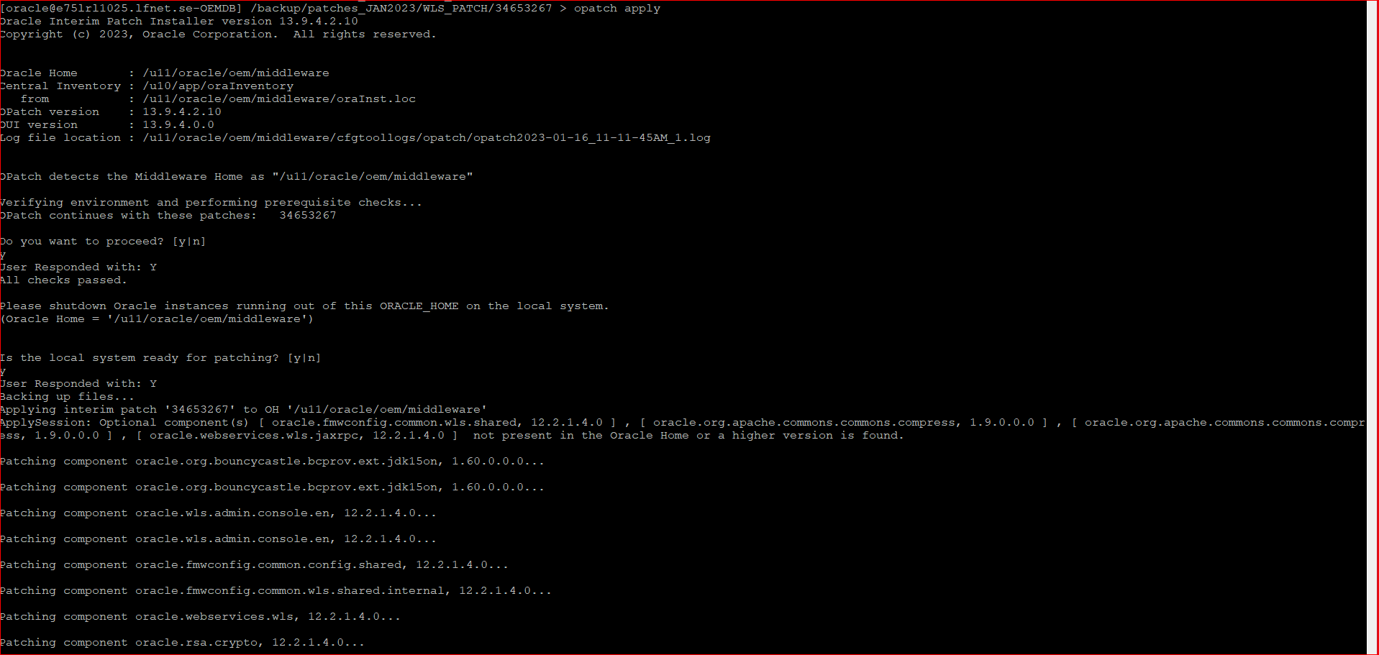
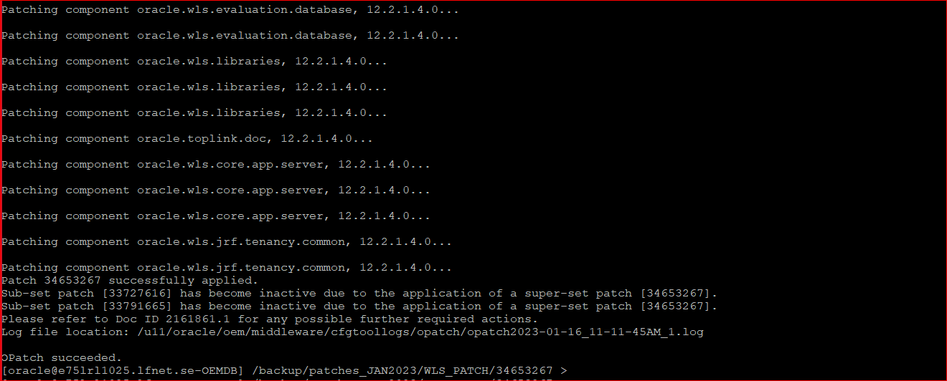

- Patch 34545596 Coherence 12.2.1.4 Cumulative Patch 15 (12.2.1.4.15)
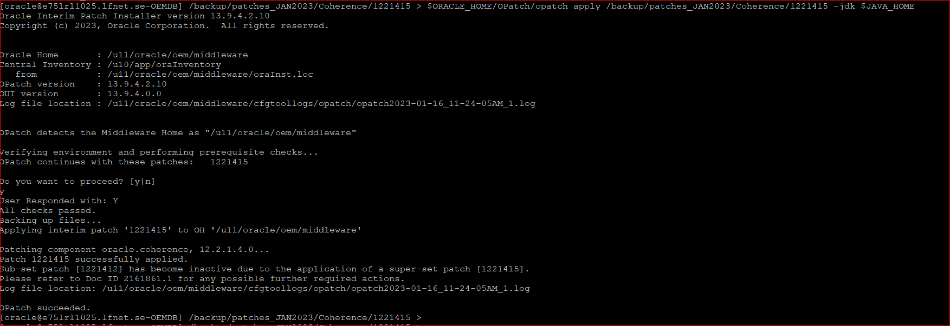
- Patch 33639718 ADR FOR WEBLOGIC SERVER 12.2.1.4.0 CPU JUL 2022
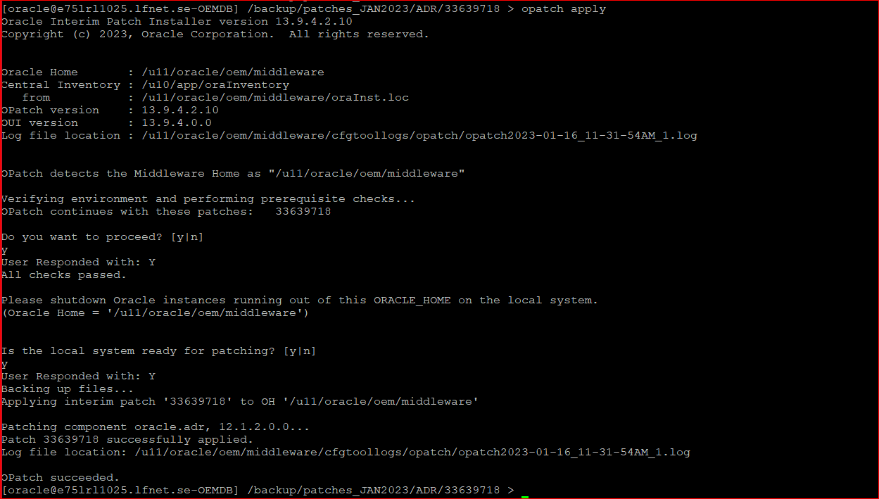
- Patch 34523462 OHS (NATIVE) BUNDLE PATCH 12.2.1.4.220823
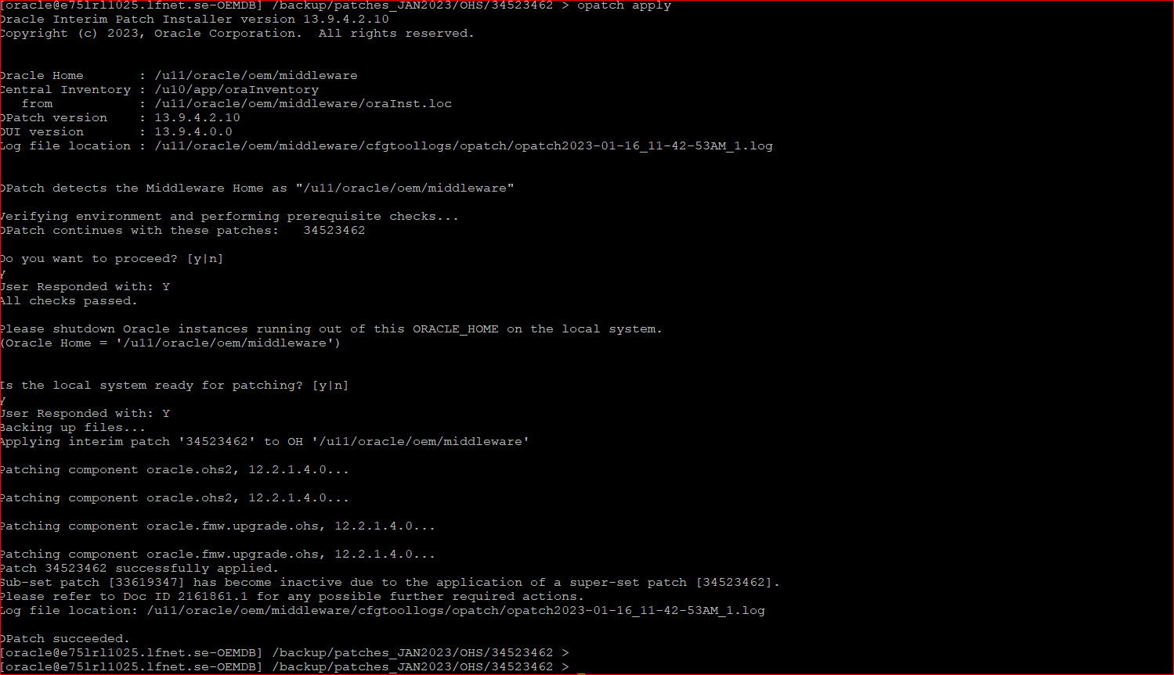
- Patch 33950717 OPSS BUNDLE PATCH 12.2.1.4.220311
Already applied so ignored.
- Patch 33877829 OSS BUNDLE PATCH 12.2.1.4.220219
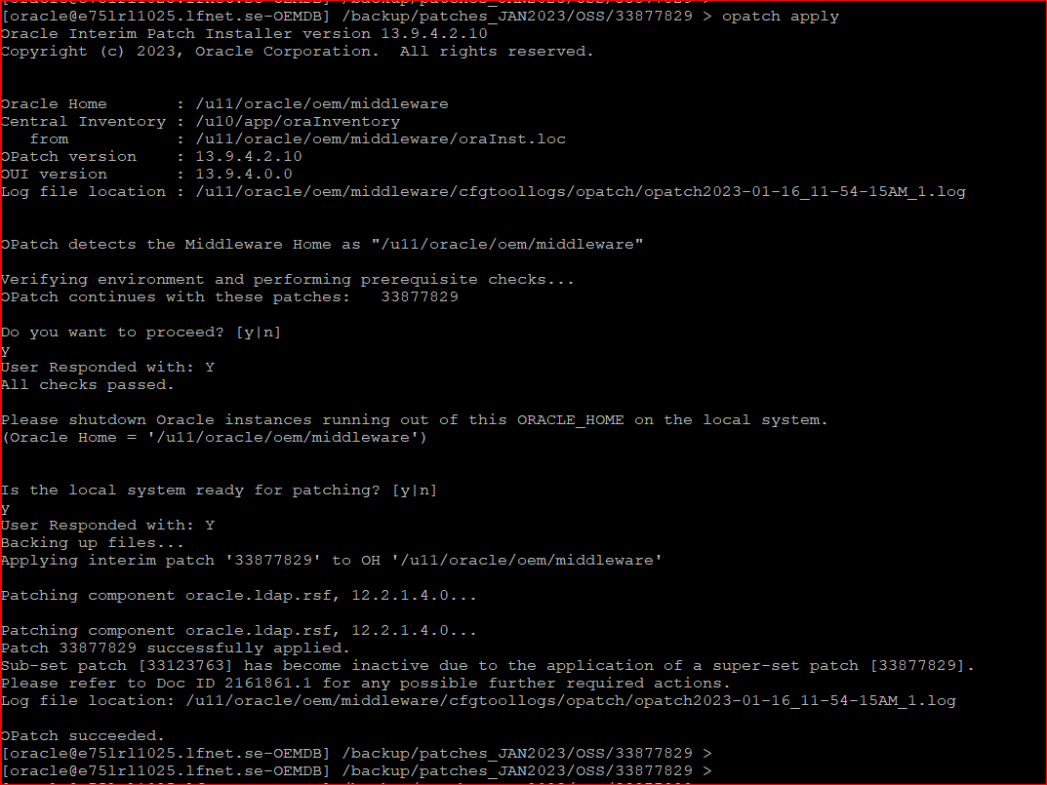
- Patch 34535558 ADF BUNDLE PATCH 12.2.1.4.220825
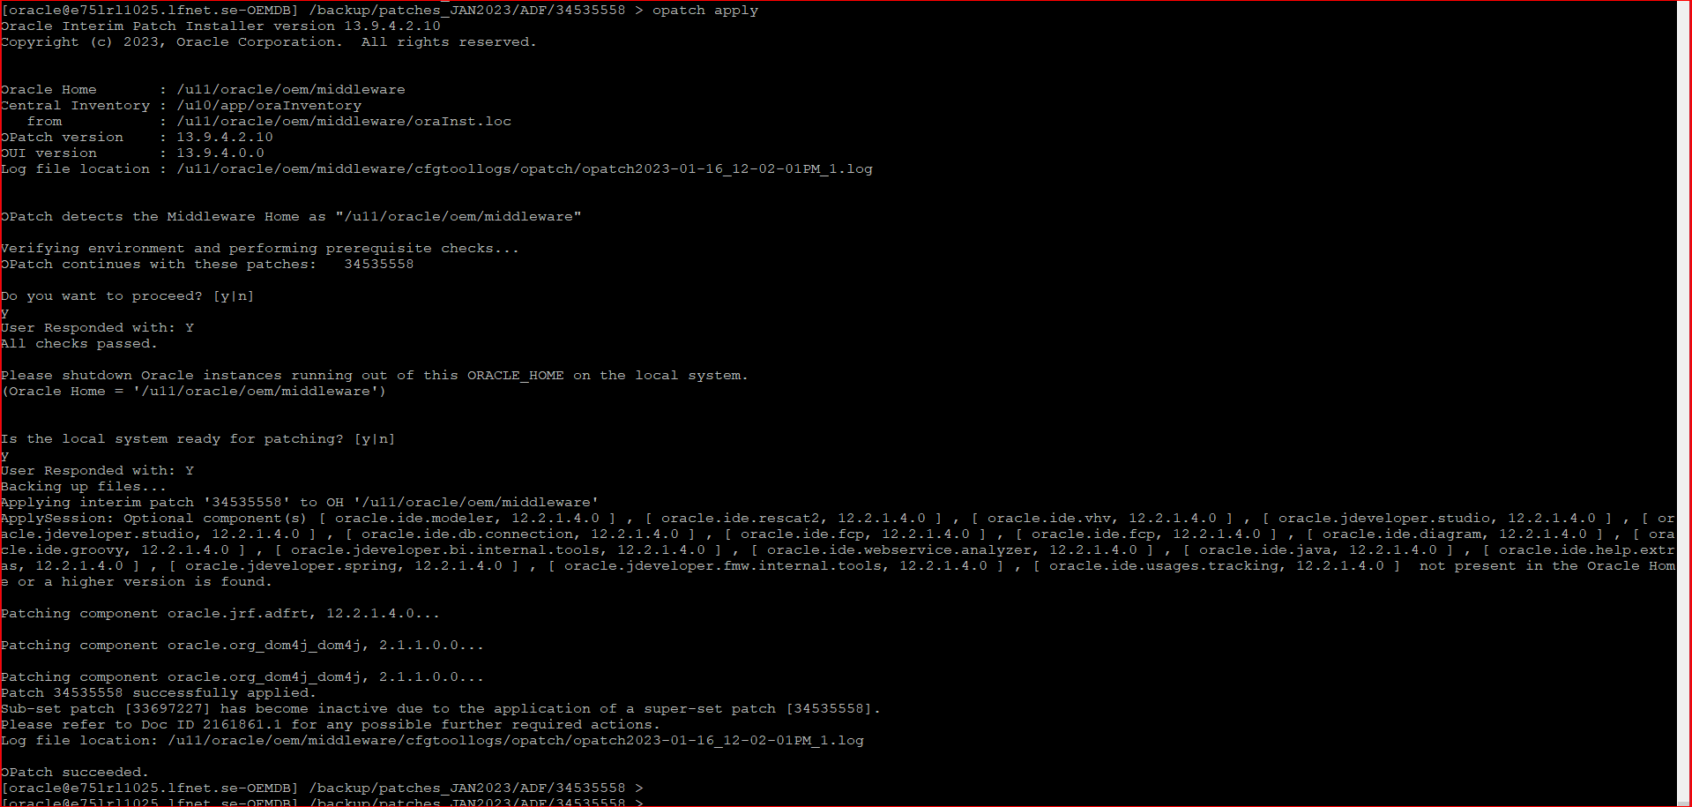
- Patch 34604561 FMW Thirdparty Bundle Patch 12.2.1.4.220915
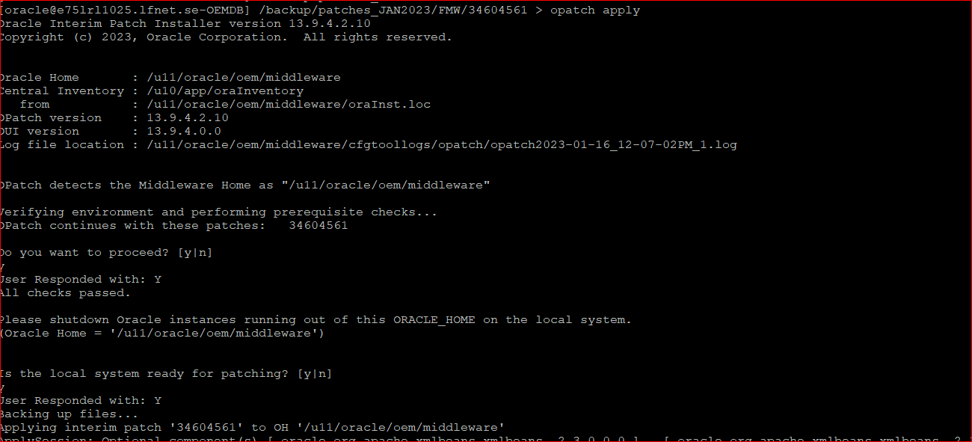
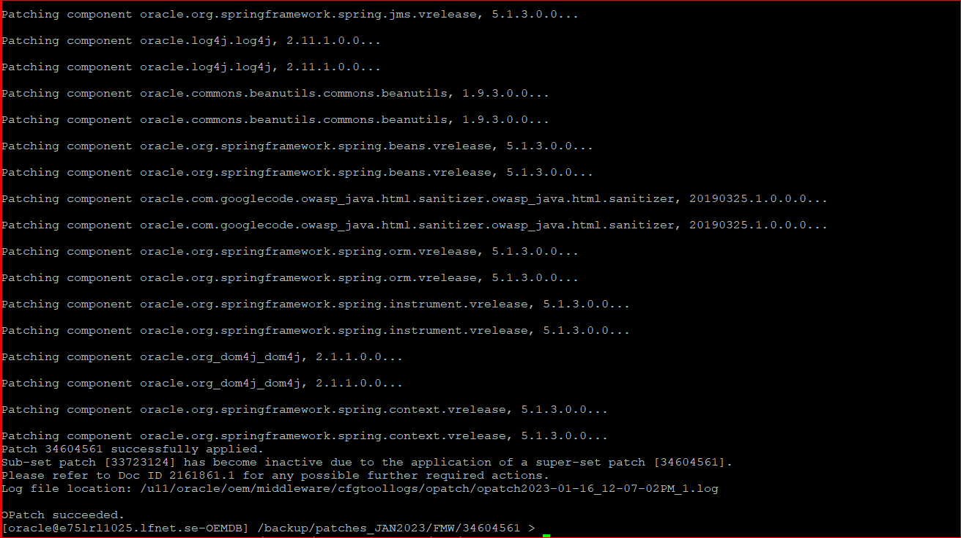
- Patch 34549208 WEBCENTER CORE BUNDLE PATCH 12.2.1.4.220825
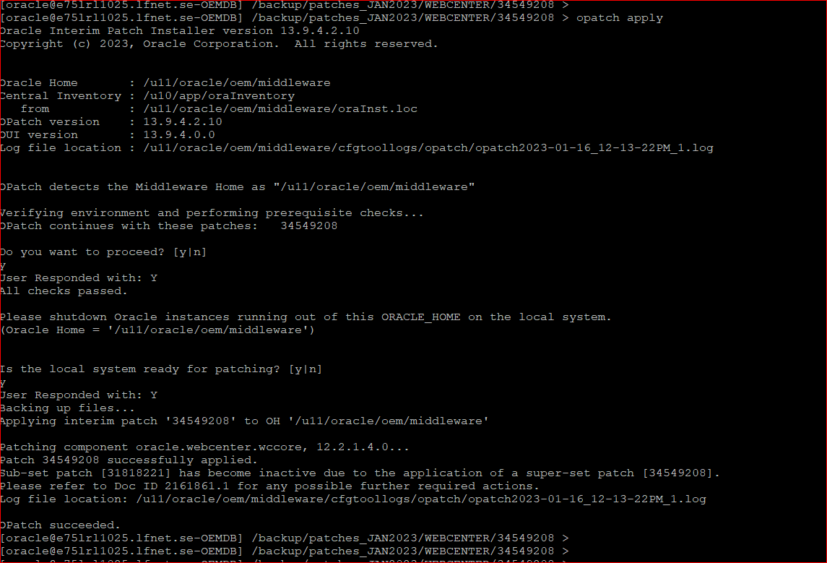
- Patch 33903365 OAM CONSOLE LOGIN FAILS AFTER APPLYING 1.80.331 JDK
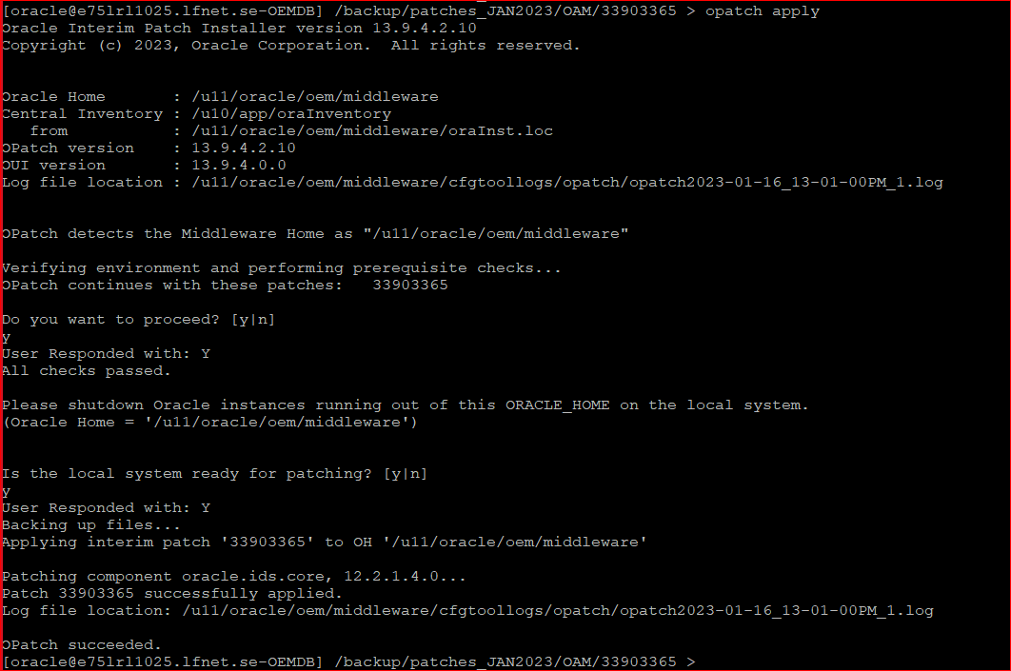

6.JDK upgrade in OMS

- File Name: p34568989_180351_Linux-x86-64.zip
- Stop OMS
$<OMS_ORACLE_HOME>/bin/emctl stop oms -all
- Go to <OMS_ORACLE_HOME>/oracle_common/
Example: <MW_HOME>/oracle_common
- Take backup of jdk directory.
$mv jdk jdk_bak
- Copy p34568989_180351_Linux-x86-64.zip to ORACLE_HOME/oracle_common/
- Unzip p34568989_180351_Linux-x86-64.zip and check the readme.txt for the instructions to install it.
$tar zxvf jdk-8u351-linux-x64.tar.gz
It will create jdk1.8.0_351 directory. Rename it to jdk.
- Confirm the version of the JDK by checking:
$<OMS_ORACLE_HOME>/oracle_common/jdk/bin/java -version
- Start OMS
$<OMS_ORACLE_HOME>/bin/emctl start oms

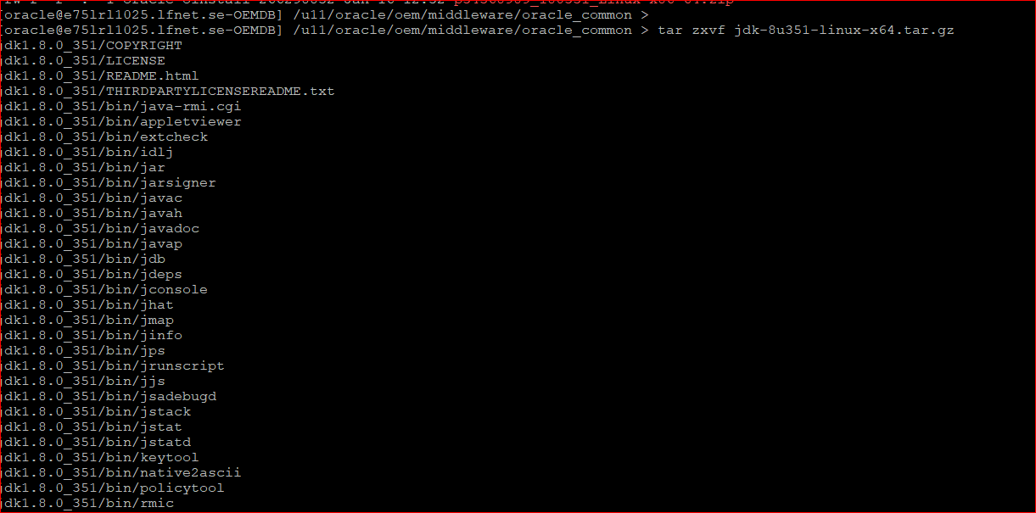

7.JDK upgrade in Agent

By default, EM 13.5 Agent uses java version "1.8.0_261"
OMS should be updated with same jdk version before upgrading it in agents.
1. Download patch
2. Stop Agent
<Agent_Base>/agent_inst/bin/emctl stop agent
3. Go to <AGENT_ORACLE_HOME>/oracle_common/
Example: <Agent_Base>/agent_13.5.0.0.0/oracle_common/
4. Take backup of jdk directory.
$mv jdk jdk_bak
5. Copy p34568989_180351_Linux-x86-64.zip to
$AGENT_ORACLE_HOME/oracle_common/
6. Unzip p34568989_180351_Linux-x86-64.zip and check the readme.txt for the instructions to install it.
$tar zxvf jdk-8u351-linux-x64.tar.gz
It will create jdk1.8.0_351 directory. Rename it to jdk.
7. Confirm the version of the JDK by checking:
<AGENT_ORACLE_HOME>/oracle_common/jdk/bin/java -version
8. Start Agent
<Agent_Base>/agent_inst/bin/emctl start agent
Before:
After:

